**APPENDIX 1**

**TRAVELLING & VLOG**

**WEBSITE**

### 

PROJECT REPORT

***by***

Dhruva Maheshwari

Vasudev

Abhijit Kumar

(Section: K23SGF)

(Roll No. 01,02,03)



**School of Computer Science Engineering**

**Lovely Professional University**

**Jalandhar, Punjab**

## December - 2023

**APPENDIX 2**

# Student Declaration

This is to declare that this report has been written by me/us. No part of the report is copied from other sources. All information included from other sources has been duly acknowledged. I/We aver that if any part of the report is found to be copied, I/we are shall take full responsibility for it.

Signature

Dhruva Maheshwari

Roll number: 01

Signature

Vasudev

Roll number: 02

Signature

Abhijit Kumar

Roll number: 03

Place : Jalandhar, Punjab

Date : 03/12/2023

### APPENDIX 3

**TABLE OF CONTENTS**

|  |  |  |
| --- | --- | --- |
| **SNO** | **TITLE** | **PAGE NO.** |
|  | Introduction……………………………………. | 1 |
|  | Objectives of Project…………………………… | 5 |
|  | Features of Project…………………………….. | 6 |
|  | Project Screenshots…………………………… | 7 |
|  | Future Scope of Project……………………….. | 10 |

### APPENDIX 4

BONAFIDE CERTIFICATE

Certified that this project report “Travel and Vlog Website- ‘TRAVEL INDIA’” is the bonafide work of “DHRUVA MAHESHWARI, VASUDEV, ABHIJIT KUMAR” who carried out the project work under my supervision.

**Dr. Palvi Soni**

Professor

ID: 29451

Department of

#### **Chapter-1**

#### **Introduction:**

**HTML**stands for Hypertext Markup Language. It was created by Tim Berners-Lee in 1991. The first version of HTML is HTML 2.0 which was published in 1999, and the latest version is HTML 5. We can save HTML files with an extension .html. It is the most basic language, and simple to learn and modify.

It contains the elements that can change/develop a web page’s look and the displayed contents. Or we can say that HTML creates or defines the structure of web pages. We can create websites using HTML which can be viewed on internet-connected devices like laptops, android mobile phones, etc. It is a combination of both hypertext and markup language.

Text that is not restricted to a sequential format and that includes links to other text is called Hypertext. The links can connect online pages inside a single or different website.

Markup Language is a language that is interpreted by the browser, and it defines the elements within a document using “tags”. It is human-readable, which means that markup files use common words rather than the complicated syntax of programming languages.

HTML is the first language you should learn if you want to go for web development. HTML is a markup language that loads fast and is also light weighted. Whenever you use your browser to contact a server, you will receive a response in the form of HTML and CSS. Many tags are supported by HTML, making your web page more appealing and recognizable. HTML5 has recently incorporated new tags and elements to aid in the development of professional-looking web pages.

## Applications of HTML:

HTML is used for various purposes. Let us take a look at them

* Web Pages Development
* Embedding Images and Videos
* Game development
* Data entry support
* Store Things On The Client-Side

**CSS**stands for Cascading Style Sheets, is a simple design language intended to simplify the process of making web pages presentable. Using CSS, you can control the color of the text, the style of fonts, the spacing between paragraphs, how columns are sized and laid out, what background images or colors are used, as well as a variety of other effects.

CSS handles the look and feel part of a web page. CSS is easy to learn and understand but it provides powerful control over the presentation of an HTML document. Most commonly, CSS is combined with the markup languages HTML or XHTML.

.

Advantages of CSS:

* **Multiple Device Compatibility**
* Superior styles to HTML**.**
* **CSS saves time.**
* **Pages load faster.**
* **Easy maintenance**
* **Global web standards**

CSS is created and maintained through a group of people within the W3C called the CSS Working Group. The CSS Working Group creates documents called specifications. When a specification has been discussed and officially ratified by the W3C members, it becomes a recommendation. These ratified specifications are called recommendations because the W3C has no control over the actual implementation of the language. Independent companies and organizations create that software.

The World Wide Web Consortium or W3C is a group that makes recommendations about how the Internet works and how it should evolve.

Cascading Style Sheets level 1 (CSS1) came out of W3C as a recommendation in December 1996. This version describes the CSS language as well as a simple visual formatting model for all the HTML tags.

CSS2 became a W3C recommendation in May 1998 and builds on CSS1. This version adds support for media-specific style sheets e.g. printers and aural devices, downloadable fonts, element positioning and tables.

The motivation for making CSS was to provide a system to style the information which is being presented (At that time, this was solely lacking), and to isolate the process of styling from that of content creation. Without using CSS, it is very typical thing for web designers to lay out pages with techniques like HTML tables that obstruct accessibility for the vision-impaired users.

**JavaScript** is a lightweight, cross-platform, and interpreted compiled programming language which is also known as the scripting language for webpages. It is well-known for the development of web pages; many non-browser environments also use it. JavaScript is both imperative and declarative type of language. JavaScript contains a standard library elements of objects, like [Array](https://www.geeksforgeeks.org/arrays-in-javascript/), [Date](https://www.geeksforgeeks.org/javascript-date-objects/), and [Math](https://www.geeksforgeeks.org/javascript-math-object/), and a core set of language like [operators](https://www.geeksforgeeks.org/javascript-operators/), control structures, and [statements](https://www.geeksforgeeks.org/javascript-statements/). JavaScript is also being used widely in game development and[Mobile](https://www.guru99.com/mobile-testing.html)application development.

JavaScript was developed by Brendan Eich in 1995, which appeared in Netscape, a popular browser of that time. The language was initially called LiveScript and was later renamed JavaScript.

Being a scripting language, JavaScript cannot run on its own. In fact, the browser is responsible for running JavaScript code. When a user requests an HTML page with JavaScript in it, the script is sent to the browser, and it is up to the browser to execute it. The main advantage of JavaScript is that all modern web browsers support JavaScript. So, you do not have to worry about whether your site visitor uses Internet Explorer, Google Chrome, Firefox or any other browser.

To start with, you need a text editor to write your code and a browser to display the web pages you develop. You can use a text editor of your choice including Notepad++, Visual Studio Code, Sublime Text, Atom or any other text editor you are comfortable with.

There are many programmers who think that JavaScript and[Java](https://www.guru99.com/java-tutorial.html)are the same. In fact, **Java is a very complex programming language whereas JavaScript is only a scripting language.** The syntax of JavaScript is mostly influenced by the programming language C.

Advantages of JavaScript:

* **Reduce the time.**
* **Provides various interfaces.**
* **Capable of front-end as well as back-end development**
* **Reduces code length.**
* **Works perfect with other programming languages.**
* **Data validation is possible on the browser itself rather than sending it off to the server.**

#### **Chapter-2**

**Objectives Of Project:**

In today's digital age, travel and vlog websites have become indispensable sources of inspiration and guidance for both seasoned wanderers and armchair travelers alike. These platforms offer a visual escape, presenting a kaleidoscope of destinations, cultural experiences, and adventures through captivating images and videos. For users, these websites go beyond mere entertainment; they serve as valuable tools for trip planning, providing practical tips, itineraries, and firsthand insights into accommodations, transportation, and local attractions.

The immersive visual content creates a virtual journey, allowing users to explore and connect with diverse cultures before embarking on their own adventures. Simultaneously, travel websites foster a sense of community, where users can share their experiences and engage with like-minded individuals. On the flip side, content creators, particularly vloggers, leverage these platforms to share their personal travel narratives, offering a unique and authentic perspective. This digital storytelling not only entertains but also facilitates cultural exchange by showcasing local customs, traditions, and lifestyles.

Beyond their informative roles, travel and vlog websites present opportunities for monetization, enabling users and creators to turn their passion for travel into a sustainable income source. These platforms, with their blend of information, inspiration, and entertainment, play a crucial role in connecting people and fostering a global community united by the love of exploration.

Despite these reasons there was an alarming lack of a digital platform catering to the needs of travelling and vlogging newbies and enthusiasts who just want to travel and vlog for fun rather than monetizing it or making it some sort of money-making scheme. In this day and age such people who just want to roam and enjoy the beauty present everywhere are very rare and should be given a proper platform. Not only that, our platform is entirely intuitive and accessible.

The **following are few of our projects most imperative objectives:**

* **Promote Tourism:**
* **User-Friendly Interface:**
* **Comprehensive Content:**
* **Interactive Maps:**
* **Vibrant Visuals:**
* **Vlog Integration:**
* **Community Engagement**
* **Mobile Responsiveness**

#### **Chapter-3**

**Features Of Project:**

* **Responsive Design.**
* **Homepage with Featured Content**
* **Interactive Maps.**
* **Destination Pages.**
* **Search and Filtering Option.**
* **People can access it from any device.**
* **User Accounts.**
* **Community and Social Features.**
* **Social Media Integration**
* **User Generated Content.**
* **Accessible to everyone.**
* **Supports Multimedia.**
* **Regular Updates**
* **Privacy and Security**
* **Feedback and Rating System**
* **Contact and Support**

In the ever-expanding realm of travel and exploration, our project envisions a dynamic and immersive travel and vlog website designed to captivate and inspire wanderlust. The homepage serves as a vibrant gateway to a world of possibilities, featuring carefully curated content that includes stunning visuals, featured destinations, and the latest vlogs. Users are greeted with a seamless and visually appealing interface that invites them to embark on a virtual journey of discovery. The intuitive navigation allows for easy exploration, with a user-friendly design ensuring accessibility across various devices, from desktops to mobile phones.

Diving deeper into the website, dedicated destination pages provide a treasure trove of information for each locale. Users can access comprehensive travel guides, insider tips, and a collection of vlogs capturing the essence of each destination. Interactive maps further enhance the experience, allowing users to visually explore points of interest and plan their own unique itineraries. The platform encourages user engagement and community building, offering social features such as comments, user-submitted content, and the ability to connect with fellow travelers. Users can create accounts to personalize their journey, save favorite destinations, and contribute to the communal tapestry of shared travel experiences.

Our project prioritizes not only the richness of content but also the seamless integration of monetization opportunities. By exploring partnerships, sponsorships, and affiliate marketing, the project aims to sustain its growth while providing users with valuable and authentic travel insights. The website's commitment to SEO optimization ensures that it reaches a wider audience, making it a go-to resource for those seeking travel inspiration and information. Through these features, our travel and vlog website aspire to foster a global community united by a shared passion for exploration, cultural exchange, and the boundless wonders of the world.

#### **Chapter-4**

**Project Screenshots:**

**Home page**

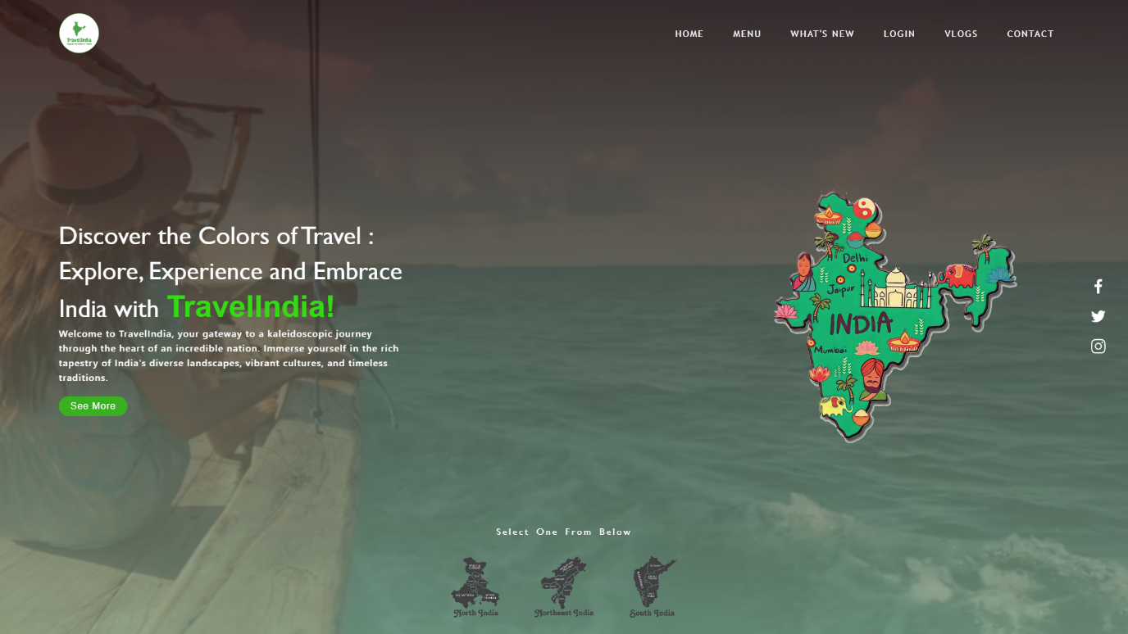

**Interaction with Map**

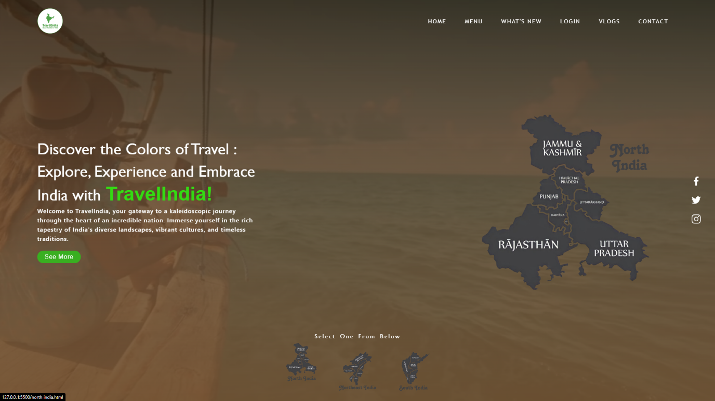

**Selecting the Location:**

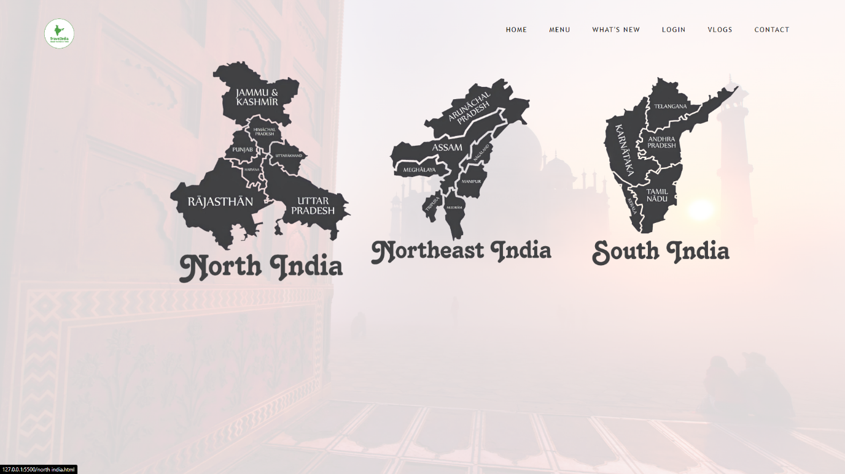

**Sign up / Log In Page**

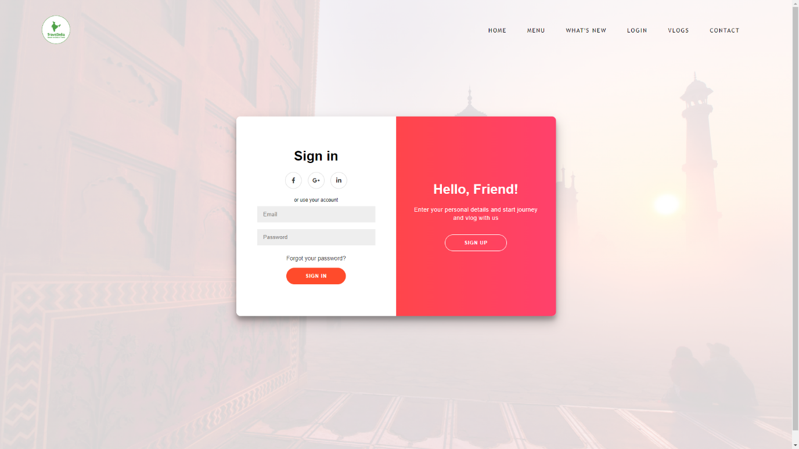

**Travel Destinations:**

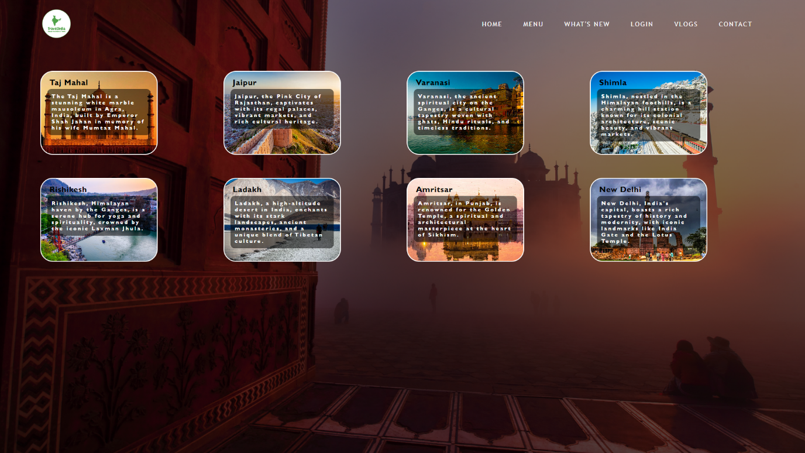

**Travel Guide for a Travel Destination**

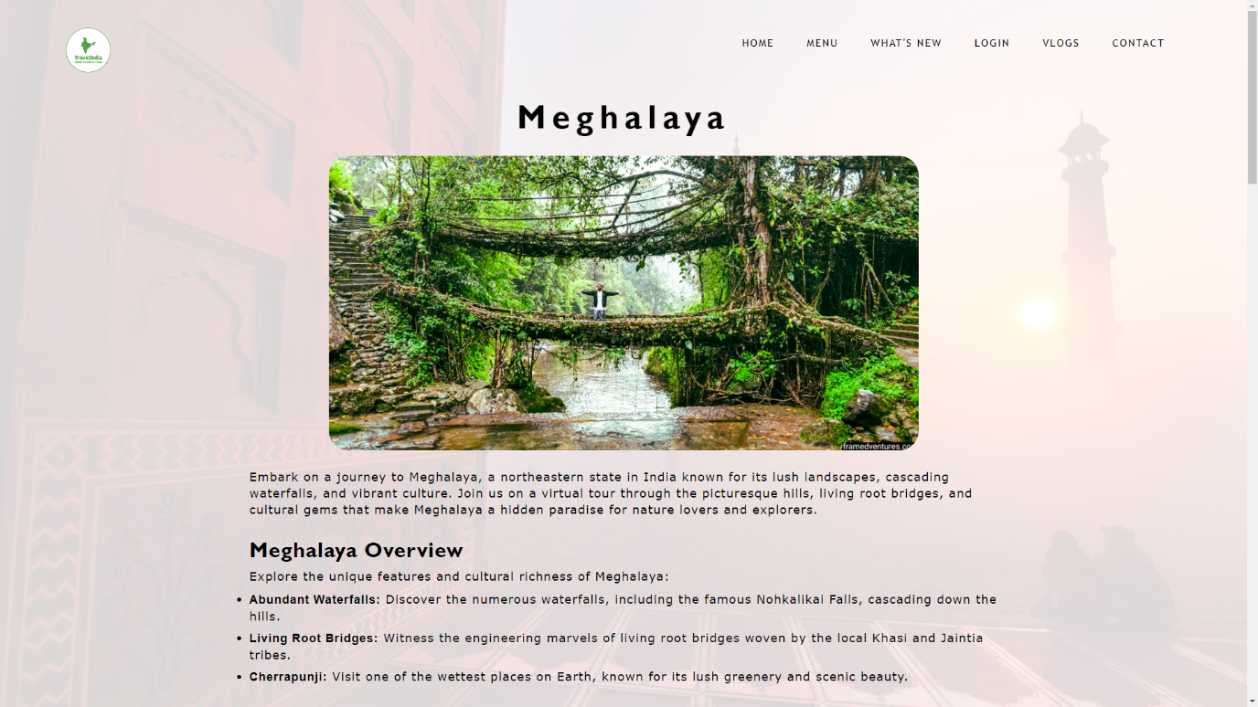

**Travel Guide for a Travel Destination**

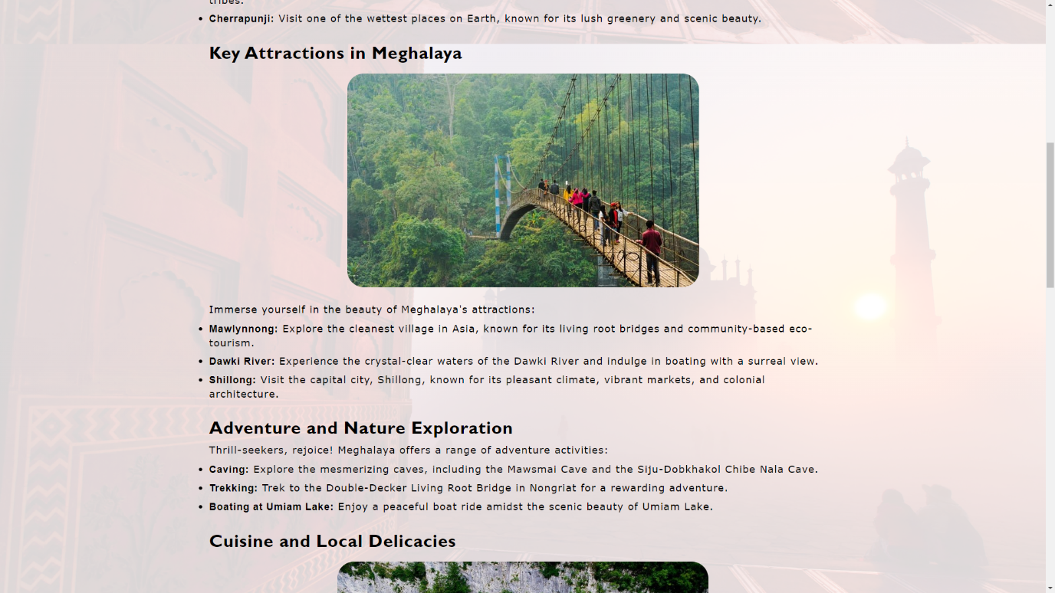

**Travel Guide for a Travel Destination**

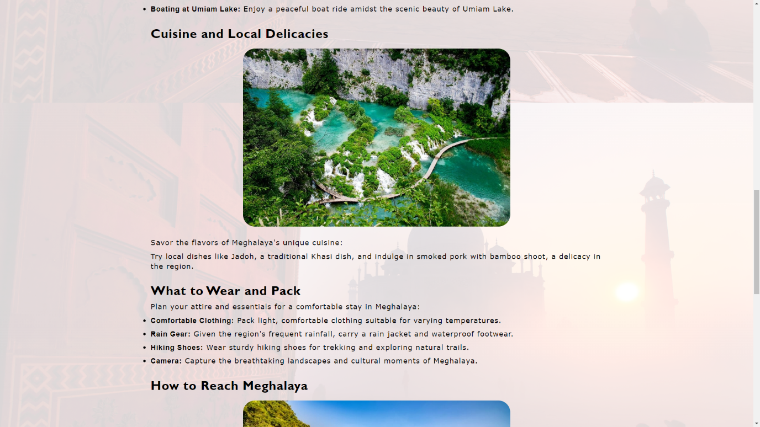

**Travel Guide for a Travel Destination**

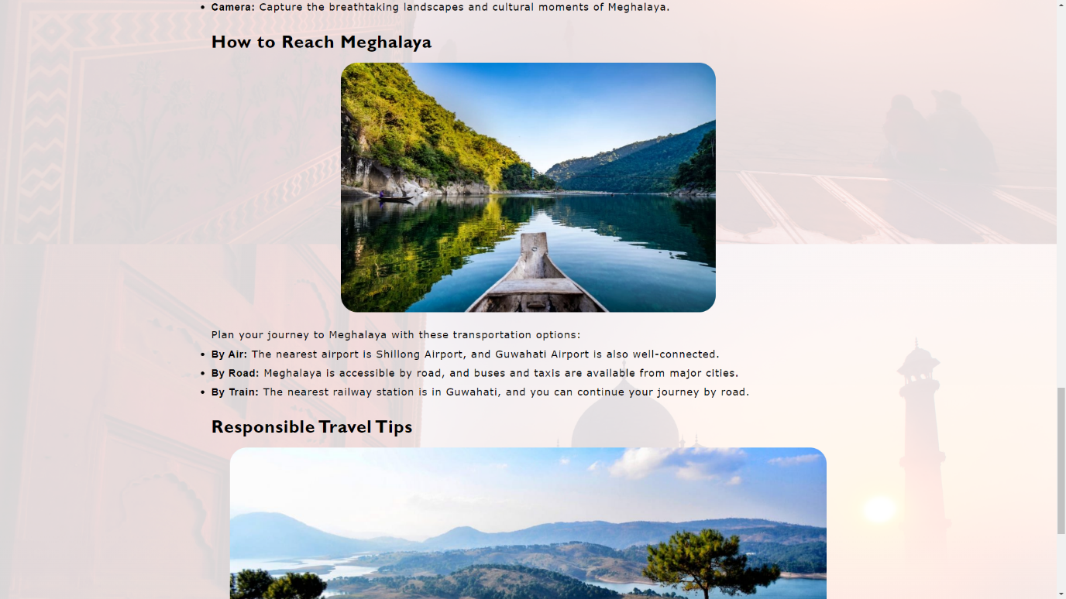

**Travel Guide for a Travel Destination**

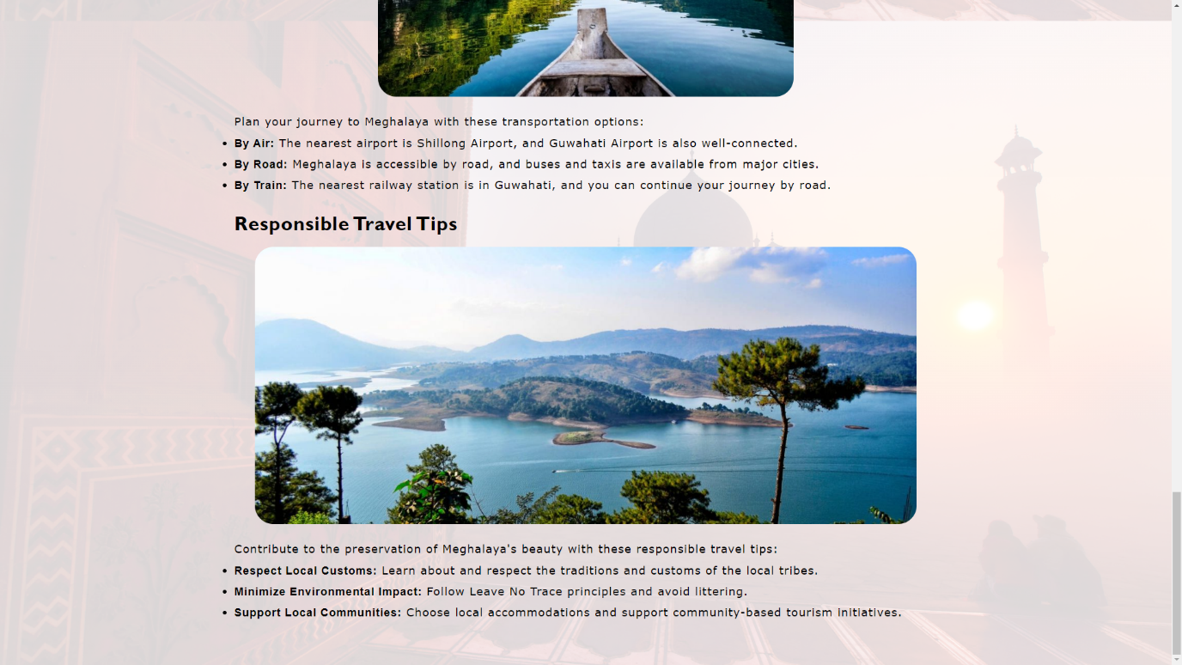

#### **Chapter-5**

**Future Scope Of Project:**

Today the world is moving towards being more digital, and digitization is the need of every business, every industry. Thus, we can say that the future scope of our travel and vlog website project is brimming with possibilities and avenues for growth. As technology advances and user preferences evolve, the project has the potential to expand and innovate in several key areas.

The future scope of our travel and vlog website project envisions a dynamic evolution that aligns with emerging trends in technology and user expectations. As the digital landscape advances, the integration of augmented reality (AR) and virtual reality (VR) technologies holds immense potential. Offering users immersive experiences through AR-guided travel exploration or VR-enabled virtual destination tours could redefine how individuals interact with and plan their journeys. Additionally, the project aims to embrace the Internet of Things (IoT) to create a more connected travel experience, providing real-time information and personalized updates through smart devices.

Expanding on the global community aspect, future developments include fostering deeper user engagement through advanced community features. This involves the creation of user-generated challenges, collaborative projects, and interactive forums, further strengthening the sense of belonging within the platform. As sustainability gains prominence, the project sees a future in promoting eco-friendly travel initiatives, incorporating information on sustainable practices, green accommodations, and carbon footprint considerations. Furthermore, the exploration of blockchain technology could enhance security for transactions, contributing to a secure and trustworthy user experience.

Global partnerships remain a key focus for the project's future, aiming to collaborate with tourism boards, travel agencies, and brands. Such partnerships could unlock exclusive content, travel discounts, and unique experiences, elevating the overall value proposition for users. As the demand for multi-language support grows, future iterations of the project will prioritize accessibility by offering content in diverse languages, ensuring a more inclusive and globally resonant platform. By continually adapting to technological advancements and user needs, the travel and vlog website project is poised to evolve into a comprehensive and innovative hub, inspiring and connecting a diverse community of travel enthusiasts around the world.

These key areas summarized are as follows:

* **Enhanced Personalization:**
* **Virtual Reality Integration:**
* **Augmented Reality Travel Guides:**
* **Expanded Community Features:**
* **Interactive Travel Planning Tools:**
* **Integration of Smart Devices.**
* **Partnerships and exclusives:**
* **Multi Language support:**
* **Eco-Friendly Travel Initiatives:**
* **Blockchain for Secure Transactions:**
* **Podcast and Audio Content:**

The above-mentioned points are the enhancements which can be done to increase the applicability and usage of this project.